ROAS Packet Tracer Lab Testing

VLAN 30 PC can ping external PC/Internet
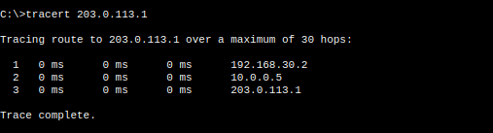
VLAN 20 PC can ping external PC/Internet
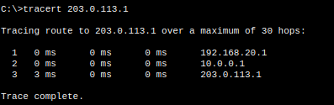
VLAN 10 PC can ping external PC/Internet
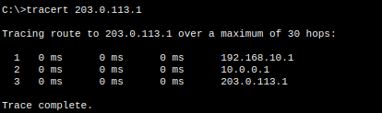
R2 can ping R1
